

**EVENT MANAGEMENT PORTAL**

**Project Guide-Ullas S**

**By: -**

A KAMAL MOHAN (CSE16006)

K NEELA DATTA (CSE16039)

K AKHIL KUMAR (CSE16047)

**Table of Contents**

Contents

1 . ABSTRACT………………………………………………………………………………………………………………………………..1

2. SOFTWARE REQUIREMENT SPECIFICATION 2

2.1 Purpose 2

2.2 Document Conventions 2

2.3 Intended Audience and Reading Suggestions 2

2.4 Product Scope 2

3. Overall Description 2

3.1 Product Perspective 2

3.2 Product Functions 2

3.3 User Classes and Characteristics 2

3.4 Operating Environment 2

3.5 Design and Implementation Constraints 2

3.6 User Documentation 2

3.7 Assumptions and Dependencies 2

4. External Interface Requirements: 2

4.1 User Interface: 2

4.2 Communication Interface: 2

4.3 Software Requirements: 2

5. System Features 2

5.1 Log-In(Students) 2

5.2 Log-In (Administration & Dhara) 2

5.3 New User Registration (Administration & Dhara) 2

5.4 Create Notice or Event 2

5.5 View Events or Notices 2

5.6 Profile Management 2

5.7 Master Admin Purpose 2

5.8 Log out 2

6. Other Nonfunctional Requirements 2

6.1 Performance Requirements 2

6.2 Safety Requirements. 2

6.3 Security Requirements 2

6.4 Software Quality Attributes 2

5.5 Business Rules 2

3. Implementation………………………………………………………………………………………………………..3

**CHAPTER 1**

***Abstract for Event Management Portal***

**ABSTRACT**

The Main Objective of Event Management Portal is to maintain a campus wide network for communication, connecting administration, Student clubs and fellow students helping them to keep themselves updated with the events happening.

sThe administration and student clubs can post and read various articles, thus promoting literary insight. There will be a section where all the event details and fests going on in the college can be shared. The administration department can share all the deadlines via multiple user logins for the students.

**CHAPTER 2**

***Software Requirements Specification for Event Management Portal***

# Introduction

## Purpose

The purpose of this document is to present a detailed description of the

The Event Management Portal. It will explain the purpose and features of the application, the User interfaces of the application, what the application will do, the constraints under which it must operate and how the application will react to external stimuli.

## Document Conventions

Main Section Title: Font: Nimbus Roman: Bold: Size: 18

Subsection Title: Font: Nimbus Roman: Bold: Size: 14

Other Text matter: Font: Nimbus New Roman: Size: 12

## Intended Audience and Reading Suggestions

This SRS would be used by the following persons:

**Master Admin:** Creates accounts for Administration and Dhara.

**Administration and student clubs:** They would be using this application to upload various events, notices and deadlines.

**Students:** They will be using this application to view all the events and notices put by administration and student clubs.

## Product Scope

Event management portal is used to manage all the activity related to event. In any event many students work simultaneously to announce the details and it is very hard to manage to go to every class. Even Faculty has to go to the classes for announcements. So, in this application we have created an interface for student clubs and faculty to put their announcements online. So, Students can directly check the events and announcements online which reduces time and work for dhara & administration.

# Overall Description

## Product Perspective

Following is the context or origin of Event Management Application. Comparison b/w the Tradition system and the new system can also be cleared through in traditional system, Students and Administration have to visit the class rooms physically for the announcements of notices or events which wastes a lot of time. After implementing The Event Management Portal, we can communicate through A mobile having an internet. Time usage will be minimized; task will be done fast.

## Product Functions

* Login as Student, Admin and Dhara.
* View Events and Notices
* Create & Delete Notices
* Create & Delete Events
* Profile Management
* Logout for Admin and Dhara users.

## User Classes and Characteristics

**Master Admin:** This user creates account for Administration and Dhara users

**Administration & Dhara**: These Users will be the sole users of the application. They can create or delete the notices and events,

**Students:** These are the users who get information from the application about various events.

## Operating Environment

**Frontend:** XML, Java

**Backend:**  Firebase Database

**Platform used:**  Android Studio.

**Operating System:** Supports only android platform.

**Smartphone:** Vivo V11 PRO (RAM of at least 2GB) and other similar phones

**Chosen testing environment:**  6.41-inch (1080 x 2340 pixels) 5:9 aspect ratiodisplay

**Software:** Software is designed to run on any platform above Android 4.1 (Jelly Bean).

**Network Requirements:**

• The project needs Internet to fully demonstrate its capabilities.

• A minimum of 5KBps continuous connection is required for showing any improvement

brought forth by the product.

• A 64 KBps connection is recommended.

## Design and Implementation Constraints

There are many constraints which are implemented in this web application. This design is only for Pc’s and not for mobile applications. Customers are limited to see only their account details. They can’t update the balance unless they add money through the bank. Only the admins of the bank are allowed to update the bank details.

## User Documentation

After the completion of the project, a well-documented user manual will be provided

## Assumptions and Dependencies

Software (android app) used in implementing the system is free of cost and the students need not purchase it. It’s assumed that client won’t change that decision on the next phases of the software development. We assume that any student is using versions above Android 4.1.1.

This project assumes that the device is connected to network.

# External Interface Requirements:

## User Interface:

The external interfaces of the Application are relative to the various users which contain independent access units in each and event management control of administration & Dhara. The User Interface defines the human-computer interaction of the Application. The system requires interaction from various users:

* The standard **existing users** or students interact with the interface within the application to view all the events and notices which are grouped according to their departments. All these operations are carried online because it is efficient and time saving.
* A new user of administration or Dhara has to meet Master admin to create their user login so as to upload any notice or event.

* The Master **Admin** is the master user of the system because they maintain the database of the existing user and grant the permissions to users.

* On Login as Administration or Dhara, the login Screen would ask for the username and password of the user. On successful verification, it would transfer the user to the main page where there would be well designed menus and sub­menus for creating an event or notice. There would also be a Logout button for the user to end his session.
* On Login as Student, he or she can view all the departments in the college and ongoing into each department, he can view all the notices and events related to that department

* The user interface for the software shall be compatible to any android above v.4.1.

## Communication Interface:

This application uses HTTP protocol to upload & get information from the server and requires no additional software to be installed on your android device.

## Software Requirements:

Following are the software used for the Application:

**Operating System**: Android OS.

**Database**: Firebase database.

# System Features

## Log-In(Students)

* **Description and Priority**

This feature will be used to Log in by the Students. These can directly get into the homepage.

They can directly view all the events and notices without any username and passwords.

Benefit Factor:8/10

Risk Factor:2/10

* **Stimulus/Response Sequences**

When he clicks on the Login as Student, he directly goes on to the homepage and he can view all the details.

* **Functional Requirements**

**Purpose:**

View all the events and notices of all departments.

**Inputs:**

No inputs will be given by students.

**Output:**

The user will be transferred to the main activity and will be displayed with all the information.

## Log-In (Administration & Dhara)

* **Description and Priority**

This feature will be used to Log in by the administration and Dhara. Only these users can Log in It is done in order to prevent any misuse of the updating events. There is also an option where you can update your password or you can get to the admin for the password.

Benefit Factor:8/10

Risk Factor:2/10

* **Stimulus/Response Sequences**

When the user gives the correct username and password combination, he/she is transferred to the main screen or the main activity which is their personalized page else they will be redirected to the login page again.

* **Functional Requirements**

**Purpose:**

To check the credibility of a user and to prevent any misuse of the product.

**Inputs:**

The input will be username and password combination

**Output:**

The user will be transferred to the main activity on successful validation and will be alerted if the validation is unsuccessful.

## New User Registration (Administration & Dhara)

* **Description and Priority**

Its purpose is to create a new user so as to update the events. To get an account he or she has to get an account created by admin.

Benefit Factor:9/10

Risk Factor:1/10

* **Stimulus/Response Sequences**

On successful validation of each data field (customer details), the registration takes place and the success message is displayed.

* **Functional Requirements**

**Purpose:**

To register a new user.

## Create Notice or Event

* **Description and Priority**

As the user (Administration or Dhara) login’s, he can view all the notices and events present. He or she can remove the notices or add new notices or events.

Benefit Factor:9/10

Risk Factor:1/10

* **Stimulus/Response Sequences**

Upon Clicking the plus symbol, he goes into another activity where he can enter all the specified details and upload it.

**Functional Requirements**

**Purpose:**

To upload an event or notice onto to the homepage.

**Inputs:**

The user must enter all the details required or asked on the screen

**Output:**

As he uploads he can see all the notices and events on the homepage.

## View Events or Notices

* **Description and Priority**

As the user(Student) login’s, he can see all the departments. Each event is present in its respective club and also the notices are present in their respective departments.

Benefit Factor:9/10

Risk Factor:1/10

* **Stimulus/Response Sequences**

Upon Clicking any of the department he can see all the notices belonging to that department and on clicking the notice he can see all the details of the notice. Similarly, Events can also be viewed in their respective clubs.

**Functional Requirements**

**Purpose:**

To view all the events and notices.

**Inputs:**

On clicking appropriate buttons, he can go to the desired department or club and view the notices or events.

**Output:**

Viewing Notices and events can be done.

## Profile Management

* **Description and Priority**

It shows the personal information of the administration or dhara user. Collects and allows options for editing (name, current password, email & phone no.).

Benefit Factor:9/10

Risk Factor:1/10

* **Stimulus/Response Sequences**

Upon Clicking the profile management button user can view Personal Information. When user clicks edit button the appropriate details can be edited. If save button is pressed user, the edited details are saved.

* **Functional Requirements**

**Purpose:**

To manage the profile related activities.

**Inputs:**

They include only clicking appropriate buttons (profile management, edit,save) for appropriate actions.

**Output:**

Viewing personal details, editing details, saving these can be done.

## Master Admin Purpose

* **Description and Priority**

He is the controller of all the accounts. He creates an account for administration and dhara

Benefit Factor:10/10

Risk Factor:4/10

* **Stimulus/Response Sequences**

He creates the account for all the users who can update or upload the events. He can remove an account or add an account.

* **Functional Requirements**

**Purpose:**

Creates account for the users (administration and dhara).

## Log out

* **Description and Priority**

This feature would enable the user (administration & Dhara) to successfully end his session and Logout of the system. After Logging Out, he/she would not be able to perform any of the updations until he/she is again Logged In

Benefit Factor:8/10

Risk Factor:3/10

* **Stimulus/Response Sequences**

On clicking the Logout Link, the session is terminated and the Login screen appears.

* **Functional Requirements**

**Purpose:**

To successfully end the user session and Logout of the system.

**Inputs:**

Clicking Logout button.

**Output:**

On successful termination of the session, the Login Page is displayed.

# 5. Other Nonfunctional Requirements

## 5.1 Performance Requirements

The Event Management Application should be able to support multiple users at a time.

## 5.2 Safety Requirements.

The Master Admin should not share his details so that only he can create new accounts and the users (Administration & Dhara) should share their usernames so that only they can upload events and notices

## 5.3 Security Requirements

This app does not allow all the users to upload the events only Dhara and administration can upload.

## 5.4 Software Quality Attributes

**Authentication Checking**: With this checking, the application will not allow an un-authorized user to upload events and notices that he/she does not allowed to do.

**Portability**: The Event Management application must be portable between all platforms of android above 4.1.1.

**Maintainability**: The Event Management application should be modular. Specifically, file contents should be easy to maintain as the contents of the database change often.

**Performance**: The Event Management application should be able to support multiple users at a time.

## 5.5 Business Rules

* A student to be able to use this system, he/she has to enter the main activity and view all the events and notices
* The student must be logged into Event Management app to be able to upload or delete an event or notice.
* A student can download the app for free.

**CHAPTER 3**

***Implementation***

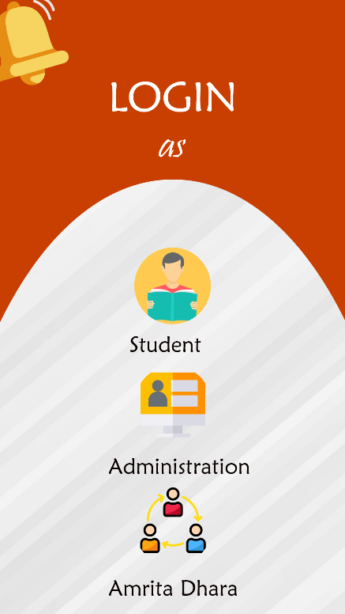 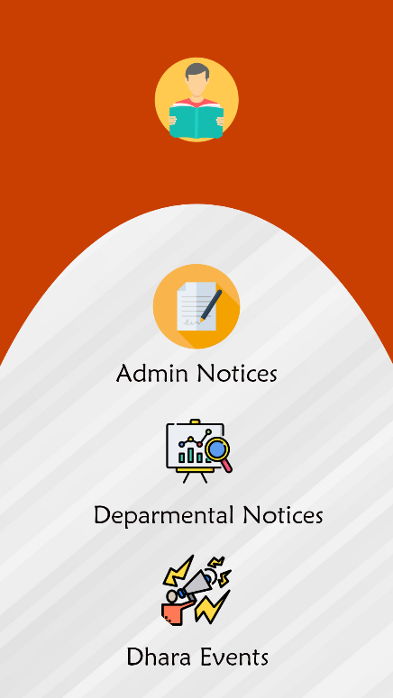

Fig 1.1 : Login page Fig1.2 : Student home page

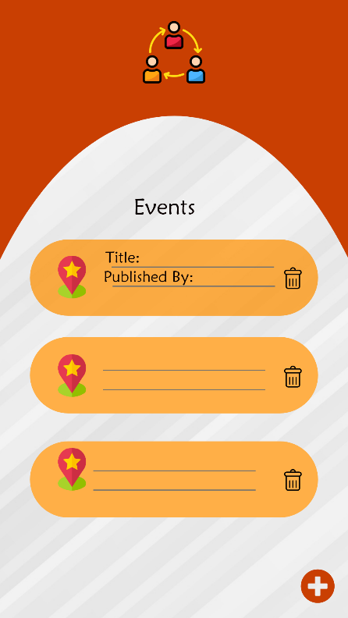 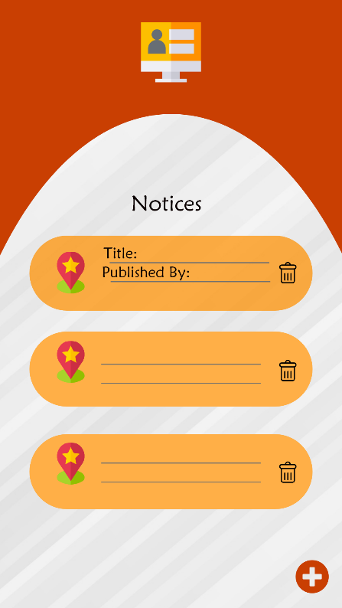

Fig 1.3: Dhara home page Fig1.4: Admin Home page

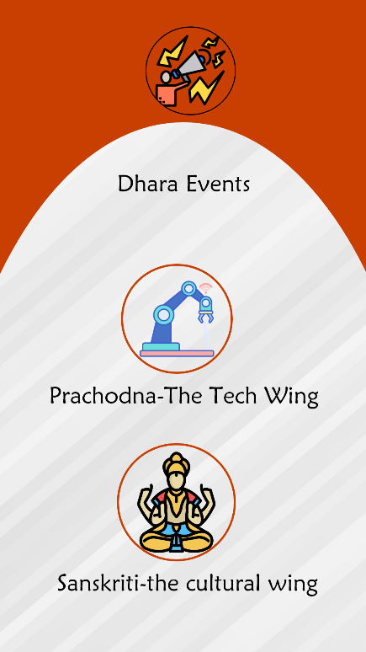 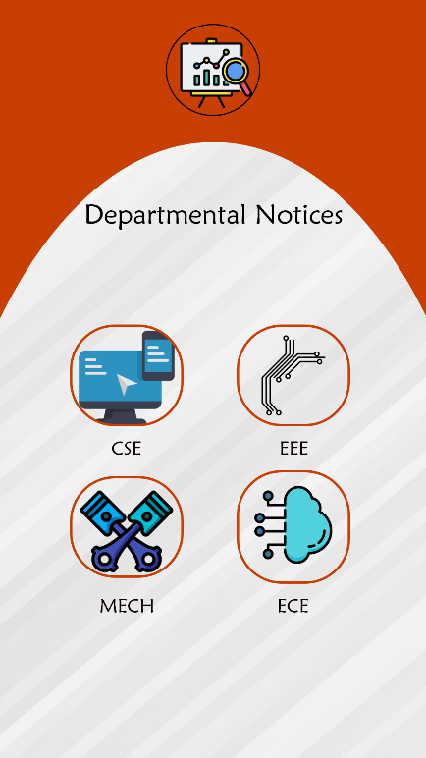

Fig 2.1:Student view of dhara events Fig2.2:Student view of dept.notices

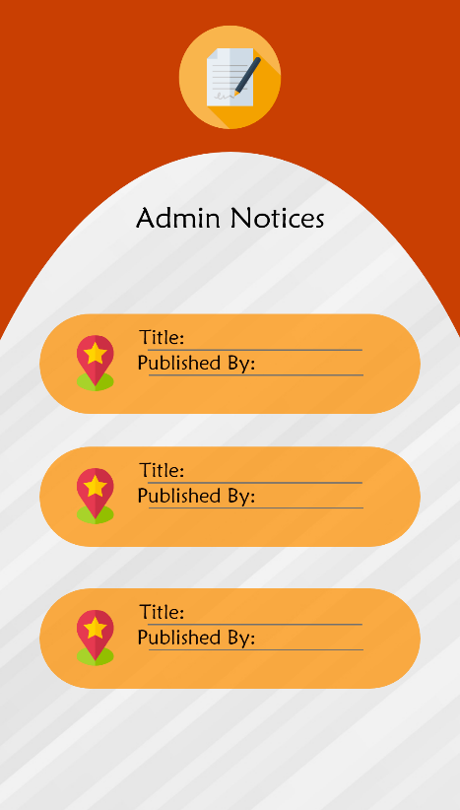 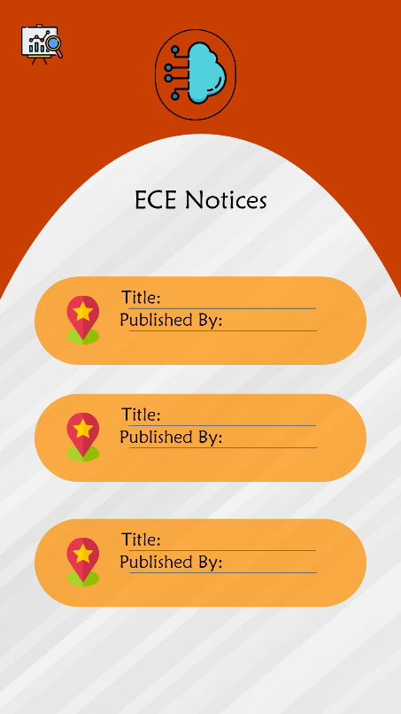

Fig2.3:Student view of admin.notices Fig2.5: Student view of ECE notices

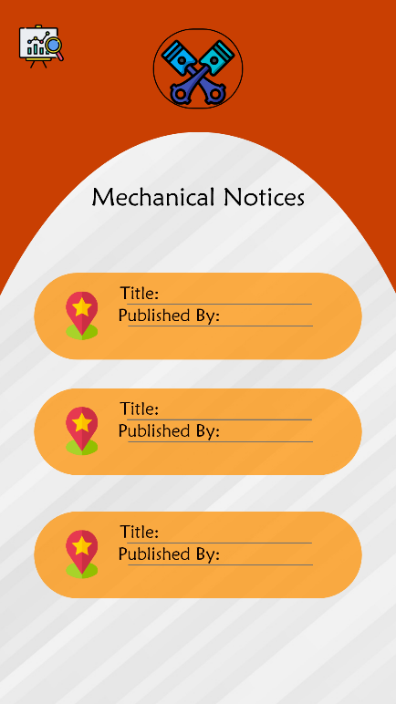 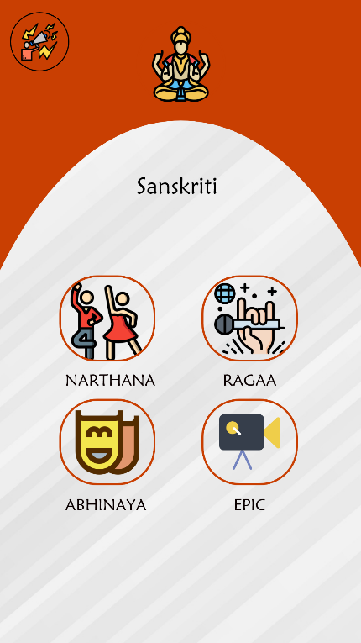

Fig 3.1:Student view of Mech notices Fig 3.2:Student view of cultural clubs

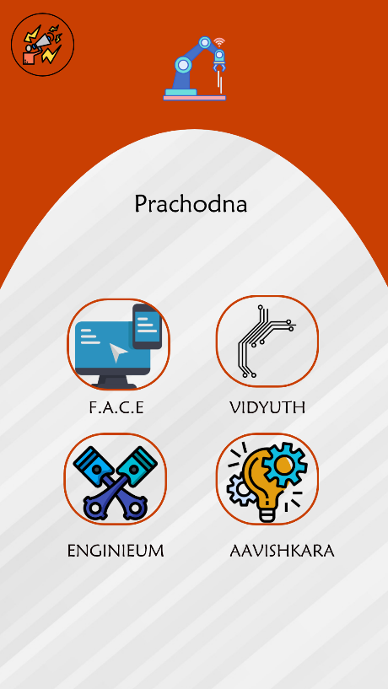 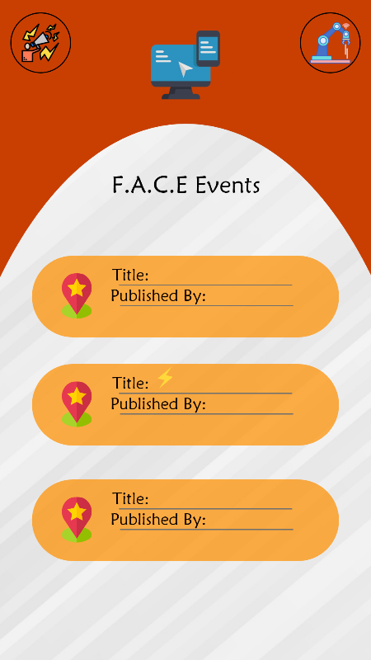

Fig 3.3:Student view of Technical clubs Fig 3.4:Student view of FACE events

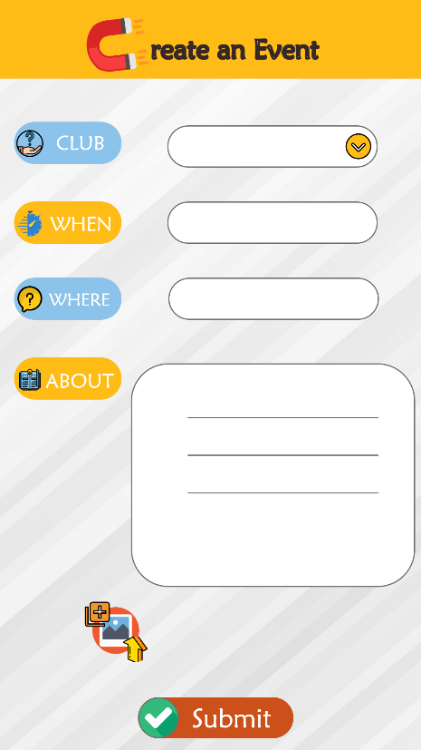 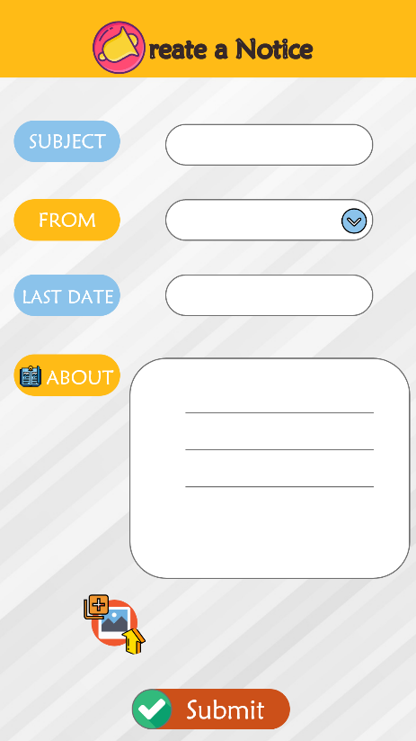

Fig 4.1:Create Event Activity for Dhara Fig 4.2:Create Notice Activity for Admin

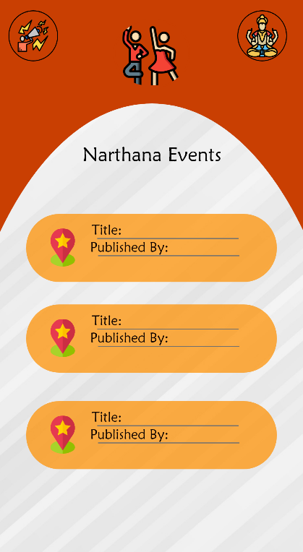 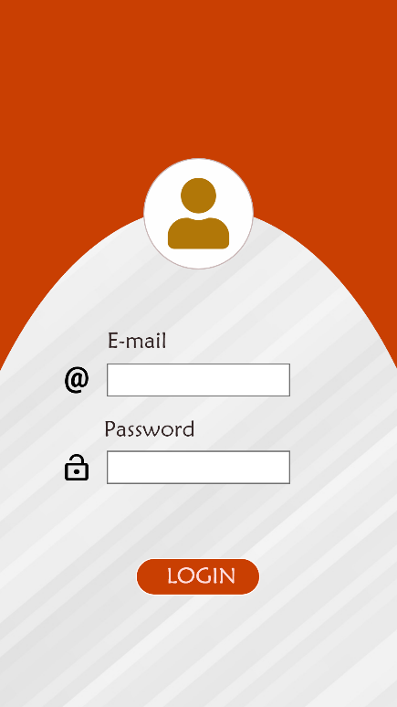

Fig 4.3:Student view of Narthana events Fig 4.4:Login page for dhara and admin

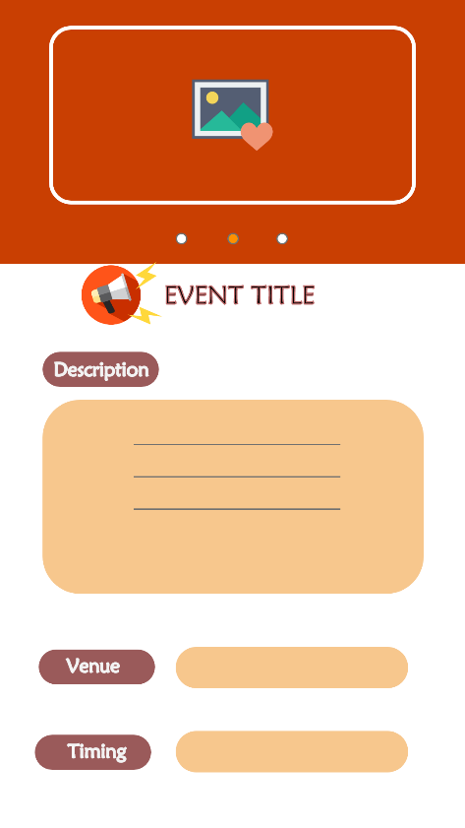

Fig 5.1 : Event/Notice description page

=x=